Topic 10: Testing Documentation (Enterprise QA & Automation Standards)
This document outlines the complete testing strategy of the system.
It is designed to meet enterprise-level QA standards used by companies like Google, Microsoft, Meta, and Amazon.
A well-structured testing strategy ensures:
• System stability
• High reliability
• Fewer production bugs
• Continuous integration support
• Scalable long-term maintenance
The testing framework is built on modern JavaScript testing tools and automated QA workflows.
---
# 1. Testing Philosophy & Goals
The project uses a multi-layer test strategy:
### **1. Unit Testing**
Test individual components, functions, and modules.
### **2. Integration Testing**
Validate communication between API, backend logic, and database.
### **3. End-to-End (E2E) Testing**
Simulate full user journeys—from login to data interaction.
### **4. Automation Testing**
Automated pipelines ensure tests run on every commit (CI/CD).
This covers all layers of system reliability.
---
# 2. Testing Architecture Overview
Below is the enterprise testing flow diagram:
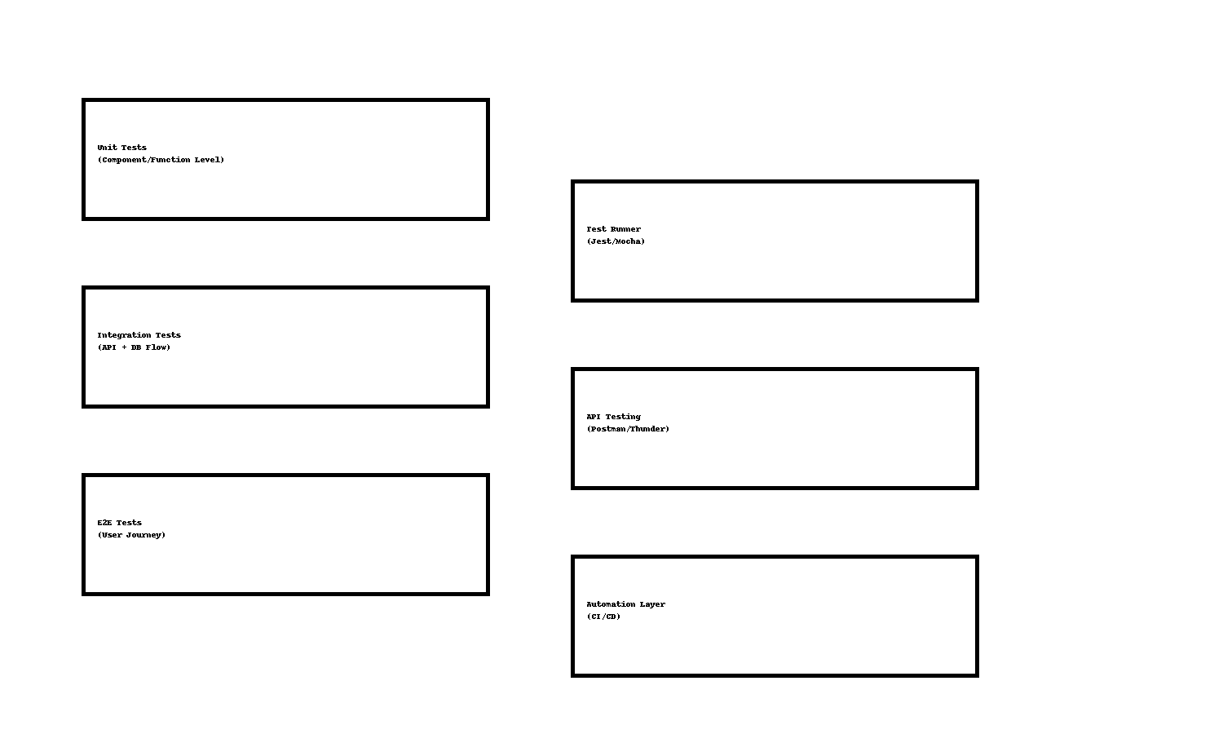
---
# 3. Testing Tools Used
The project uses a wide stack of modern tools:
• **Jest** – Unit testing
• **Mocha + Chai** – Backend functional tests
• **Supertest** – API endpoint testing
• **Postman/Thunder Client** – Manual API verification
• **Cypress / Playwright** – End-to-end UI testing
• **MongoDB in-memory server** – Fast isolated test database
• **CI/CD Integration (GitHub Actions)**
Each tool contributes to a scalable, automated QA pipeline.
---
# 4. Unit Testing Strategy (Frontend + Backend)
Unit tests ensure that each function behaves correctly in isolation.
### Example Unit Test (Pseudo):
```
test("should hash password correctly", () => {
const hashed = hashPassword("myPass123");
expect(hashed).not.toBe("myPass123");
});
```
Frontend components are also tested:
```
render(<Login />);
expect(screen.getByText("Login")).toBeInTheDocument();
```
Benefits:
• Early detection of defects
• Extremely fast execution
• Forms foundation of entire QA pipeline
---
# 5. Integration Testing
Integration tests ensure that backend routes interact properly with database operations.
### Example Integration Flow:
1. Create test database instance
2. Hit `/api/auth/register`
3. Verify stored user in DB
4. Hit `/api/auth/login`
5. Validate token generation
This validates real-world behavior between modules.
---
# 6. End-to-End (E2E) Testing
E2E tests simulate actual user journeys.
Example scenarios:
• User registers → logs in → views dashboard
• Admin adds book → verifies listing
• User interacts with book details page
Tools used: **Cypress**, **Playwright**, **Selenium (optional)**.
E2E tests ensure UI + Backend + Database work together flawlessly.
---
# 7. Manual Testing (QA Team Practices)
Manual test checklist:
• Form validation
• Button functionality
• UI responsiveness
• API input/output validation
• Admin access verification
• Error message correctness
QA testers use Postman/Thunder for rapid endpoint inspection.
---
# 8. CI/CD Testing Automation
Tests run automatically on every push using GitHub Actions.
Automation benefits:
• Prevents bad code from entering production
• Ensures stable builds
• Enables continuous delivery
• Reduces developer workload
Example CI Script:
```
name: Run Tests
on: [push]
jobs:
test:
runs-on: ubuntu-latest
steps:
- uses: actions/checkout@v2
- run: npm install
- run: npm test
```
---
# 9. Performance Testing (Advanced)
Optional enterprise testing:
• Load testing using K6
• Stress testing APIs
• Response time metrics
• Monitoring using Grafana/Prometheus
These tests help ensure the system performs well under heavy load.
---
# 10. Test Coverage & Reporting
Coverage tools such as **Istanbul** provide insights:
• Which lines are tested?
• Which functions are missing tests?
• How strong is backend coverage?
Reports include:
• Line coverage
• Branch coverage
• Function coverage
---
# 11. Conclusion
This testing documentation outlines a full enterprise-grade QA pipeline.
It covers unit testing, integration testing, E2E testing, automation, and performance testing—ensuring the system remains stable, scalable, and production-ready at all times.
This concludes **Topic 10: Testing Documentation**.

